# 

# Everything you need to know about *proving* limits:

So the formal definition of limits is weird. It’s forcing an intuitive concept into a “predicate logic paradigm”. But you need to know this for your final exam so let’s do this! First, knowing you, you remember the khan academy video on this well enough. If not, watch it.

## Definition

let’s start with the formal definition of a limit for MAT137:

$$if f\left(a,b\right)→R and c∈\left(a,b\right)$$

$$we say that \lim_{x→c}{f\left(x\right)=L}$$

$$AND$$

$$∀ϵ>0, ∃ δ s.t. 0<\left|x-c\right|<δ → \left|f\left(x\right)-L\right|<ϵ$$

Before I get into the intuitions of this, here’s a visual of $\lim_{x→1.6}{x^{2}}$ with this formula. I’ll explain the bands in the next section.

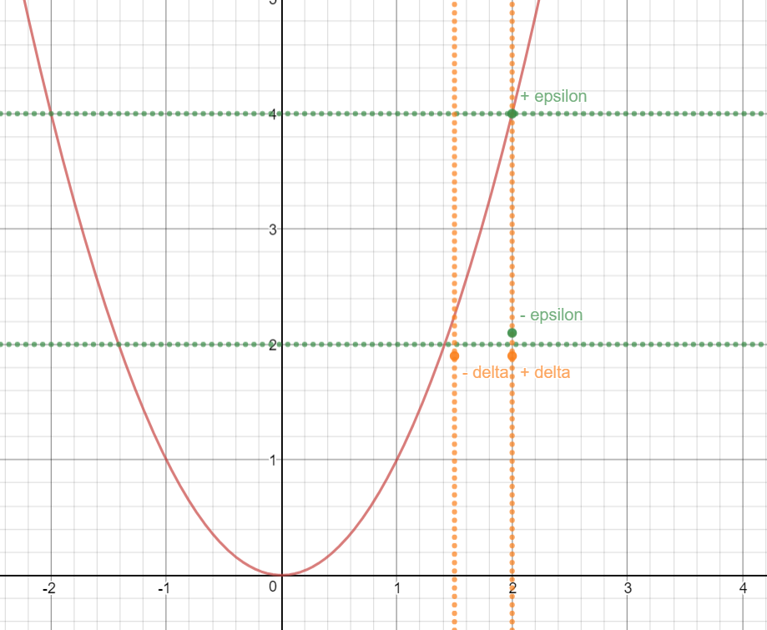

Notice:

* how the notion of a absolute value is translated bands. In the graph. algebracally you could do $± \left(x-c\right) and±\left(f\left(x\right)-L\right)$. Visually, you get the two bands.
* That we first choose an epsilon band, then choose the delta band to fit inside the delta band (*For all* epsilon, there *exists* a delta s.t. …)

This means that for a limit to exist , no matter what epsilon band I choose, I will be able to find a delta band that will fit inside there \***IF\*** the limit exists. So for example:

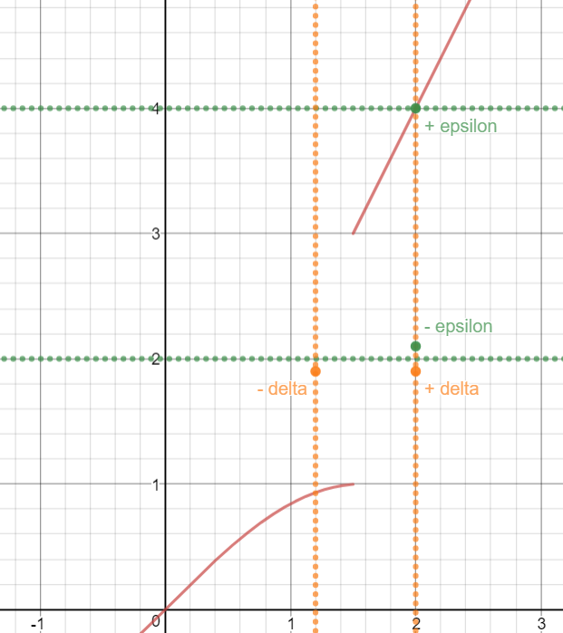

This function doesn’t have any limit at x = 1.5. Notice that we just broke the predicate logic definition here. Since we could choose any epsilon range we want (and all of them must be permitted because it starts $∀ ϵ$), and there must exist a delta range where all points in the delta range are in the epsilon range (and hence $∃δ)$. There’ll ALWAYS be some points outside an epsilon range no matter how small we make delta (and by the definition, the delta band cannot be zero). Mathematically, this could be understood as breaking the $\left|f\left(x\right)-L\right|<ϵ$, since f(x) – L will be GREATER than epsilon.

* It could also happen that you choose a ***bad*** delta band, for example:

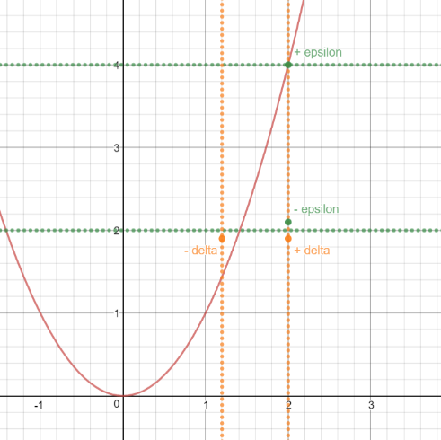

In this graph, the delta band has broken the rule, since some points are in delta, but NOT in epsilon. Alebraically this is represented by the $\left|x-c\right|<δ → \left|f\left(x\right)-L\right|<ϵ$.Notice that in the first graph, there are points that are in epsilon but not in delta. That’s fine: if we look at the since the algebra is ***not $\left|f\left(x\right)-L\right|<ϵ→ \left|x-c\right|<δ .$***

* For the delta band, you could also write

$$delta band=x∈(c- δ, c+ δ)$$

This will be useful for more complicated limits.

## Nuances

Now, a couple of nuances to understand:

* Don’t confound the lim(x->c) f(x) = L with the definition of a continuous function, which is defined as

$$\lim_{x→c}{f\left(x\right)=f\left(c\right)}$$

Which I think you’re smart enough to see this is self-evident.

* So the obvious meaning of a limit is that as x becomes arbitrarily small, we converge on L. In predicate logic, this is shown with the $∀ ϵ$ and $\left|f\left(x\right)-L\right|<ϵ$, since epsilon MUST be able to get arbitrarily small. THIS is the key to getting arbitrarily close to point.
* Delta is dependent of epsilon, since you first choose epsilon (comes first in the predicate definition). This will come in handy later
* If your representing the band with algebra on the graph, you must use open set notation i.e. (x-delta, x+delta) interval, due to the delta being strictly less than the equation when putting it on the graph
* We’re NOT finding the limit, we’re proving the limit. This is different, since in most of these cases, the limit will be given.
* For the delta inequality, it starts with a $0<…$, while the epsilon inequality doesn’t. This is because we want to reach where F(x) -L = 0 to not have a *single* solution. Also, f(c) doesn`t need to equal L, since L is a value we chose. it’s legitimate to say f(x) – L since L is not dependent on f(x).
* (for variations of the definition, and the results they give, see assignment two answers).
* You’ll notice that the combo $∀a, ∃b…$ will almost always make you boil down to choosing a ‘b’ in function of ‘a’ , ex.

$$b\left(a\right)=2a$$

This is normal, as you want every ‘b’ to fit with the parameters of ‘a’.

## Going through a proof of a limit:

There is a lot of weird steps here, since the predicate logic/proof paradigm we’re using here is un-intuitive at first glance. I’ll explain every step of the way. To get a good understanding.

***Prove that:***

$$\lim_{x→3}{4x+1=13}$$

First, you must establish the goal: you must get f(x)-L be less than epsilon, since this is not a given. Since epsilon can be arbitrarily small, it is the ‘converging to’ part of your equation. In mathematical practice, this means that $\left|f\left(x\right)-L\right|<ϵ$,as it follows from the definition of a limit. Now we want to assume there exists a delta band:

$$0< \left|x-c\right|= \left|x-3\right|<δ$$

Note that there are a lot of ways of representing the delta band algebraically, and some could be useful in different cases:

$$x∈\left(3-δ, 3+ δ\right)$$

$$⇔$$

$$\left|x-3\right|< δ$$

$$⇔$$

$$-δ< x-3<+ δ$$

$$⇔$$

$$3-δ< x<3+ δ$$

Through the assumption that you have a delta band, you want it to imply:

$$\left|f\left(x\right)-L\right|= \left|(4x+1)-13\right|<ϵ$$

You want to imply the next equation because the goal is to get this equation could be less than epsilon. This process of finding such an inequality is called “ [Rough work] ”, and should be indicated at the beginning of the paper.

To show this implication is possible, you could work from the assumption forwards, or ‘find’ the assumption by working backwards.

If we wanted to work forwards, we could do:

$$\left|x-3\right|<δ$$

$$4\left|x-3\right|<4δ$$

$$\left|(4x+1)-13\right|<4δ$$

From here, you could set $ϵ=4δ$. This was explained in the “nuance” section, and in more detail using the next method.

Most times, you’ll be working backwards.

you will start off with “ f(x) – L ” and work your way towards the first equation[1]. You are NOT allowed to change the ultimate value of the function; you must massage it by multiplying by 1, or adding 0, or combining/separating terms:

$$=\left|\left(4x+1\right)-13\right|$$

$$=\left|4x-12\right|$$

$$=4|x-3|$$

(you’re allowed to factor out # from abs. vals.)

Now you got yourself to a familiar equation: you got $\left|x-3\right|$. You could replace this by delta. Why could you do that? Because we’re assuming that $\left|x-3\right|<δ$.

We can know replace that into the equation.

$$=\left|4x-12\right|<4δ$$

This will happen for every **linear** equation.

Notice that the equality switched to an inequality. This is part of the definition, since $\left|x-3\right|<δ$. This is also crucial to the end goal, that being f(x)- L < epsilon. So how do we continue to get to epsilon? First, remember that delta is defined as follows

$$∀ϵ, ∃δ…$$

This statement implies an important rule in the proof paradigm:

Since delta is dependent on epsilon, any epsilon band I choose, delta band should be able to automatically adjust. This fits the idea of “for all epsilon, there exists a delta s.t. …”. Therefore we could think of delta as a function: $δ(ϵ)$. This means I can choose my delta to be what I want in respect to epsilon, since I want a delta range to exist for any epsilon I choose. It will not happen that a delta band has points outside the epsilon band when using this method (unless you made a mistake)

Since delta could be a function of epsilon, and we could make delta what we want[2], it is legitimate to replace delta with a function of epsilon that will get rid of the 4 in front[3]. So, for our example, let $δ=\frac{ϵ}{4}$

$$<4δ=4\frac{ϵ}{4}=ϵ$$

Graphically, this means that is we choose an epsilon range of $±2$, delta should be $±0.5$.

Now you’ve got a chain of logic that brings you from f(x)-L … < … $ϵ$. You can now formally prove the limit exists. To get 100% on your test, follow these steps:

1. For some reason, I must specify $ϵ>0$ instead of referencing the definition of a limit. So:

**Let $ϵ>0$ be given**

1. You must set your $δ$. Since you must find that a delta exists for all epsilons, you should set delta to be a function of epsilon. Through your rough work, you figured out the optimal value of $δ$ that will bring you to your goal

**Set $δ=\frac{ϵ}{4}$**

1. You can now choose many methods, but the most common and the one followed for this proof is the one starting with $\left|f\left(x\right)-L\right|$.
$$\left|f\left(x\right)-L\right|= \left|4x+1-13\right|$$

$$= \left|4x-12\right|$$

$$= 4\left|x-3\right|$$

2. Through the definition of limit, you’re allowed to replace x-3 by delta. Remember that this is because delta is a linear equation:
$$< 4δ$$

3. Now you could replace delta with epsilon…

$$<4\frac{ϵ}{4}=ϵ$$

You know have an inequality saying that $\left|f\left(x\right)-L\right|<ϵ∴Q.E.D.$

Now let’s write this 100% properly:

Let $ϵ>0$ be given, and $δ=\frac{ϵ}{4}$

Assume $0< \left|x-3\right|<δ=\frac{ϵ}{4}$

$$\left|f\left(x\right)-L\right|= \left|\left(4x+1\right)-13\right|$$

$$= \left|4x-12\right|$$

$$=4\left|x-3\right|$$

We now replace $\left|x-3\right|$ by $\frac{ϵ}{4}$

$$<4\left(\frac{ϵ}{4}\right)=ϵ∴Q.E.D.$$

## Proof a limit with a bound:

Now let’s proof a non-linear limit:

$$\lim_{x→5}{x^{2}+2}=27$$

Remember, we could manipulate delta bands, so we’ll work with them algebraically:

$$0< \left|x-c\right|= \left|x-5\right|<δ$$

Through this fact, you want it to imply:

$$\left|f\left(x\right)-L\right|= \left|(x^{2}+2)-27\right|<ϵ$$

Now let’s start with the latter statement and try to find were we could replace delta and then be able to get an epsilon in here. Starting with the later equation:

$$= \left|(x^{2}+2)-27\right|$$

$$= \left|x^{2}-25\right|$$

$$= \left|x+5\right|\left|x-5\right|$$

We now have $\left|x-5\right|$, so we can replace it with delta and change the equality to an inequality[4]

Last time we got here, we had a constant in front of the delta. This time, we have a function based on x. No ‘x-5’ appear in our definition, so what we’ll do to get rid of it is something called bounding. What this means is that we’ll find the largest possible value this function could attain by choose a delta range. We must choose a delta range to determine what’s the largest value the rest of the function will have. You might think that this screws with the fact that the delta band must fit with an appropriate epsilon band, so choosing a value for delta to solve this problem will screw with the math. However, the ‘bound’ we’ll find will be incorporated in how we relate delta to epsilon (i.e. $δ(ϵ)$), so it will work out in the end. The purpose in choosing this value is that any smaller value of delta should also work. This is a consequence epsilon and delta being able to get arbitrarily small, and ultimately that is what we want (it’s the whole idea of the limit). For example, let delta be +/- 1 from the limit:

$$before choosing delta: x∈(5-δ, 5+δ)$$

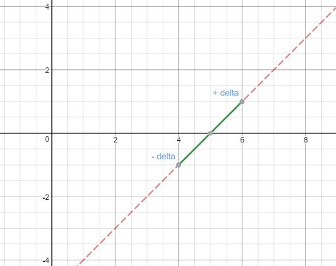

$$after choosing delta:x∈(5-1, 5+1)$$

This means that the max value would be 1. Notice that we’re not looking at the max value of x. all we care about with x is that it doesn’t explode f(x) if we plug in a value in the range. For example, if the range was $x∈(-1,3)$ and the function was $\frac{1}{x}$, then $\frac{1}{0}$ would be a problem. In that scenario, you choose a different bound. We can know work towards” $\left|x+5\right|$” and see what’s the max value that function Will achieve.

recap:

* That we’re choosing a value for delta and then figuring out the value of the bound. We can choose any delta as long as the following delta band doesn’t do anything weird, i.e. no discontinuities or asymptotes. Let’s say you’re trying to bound 1/x. You don’t want this to happen:

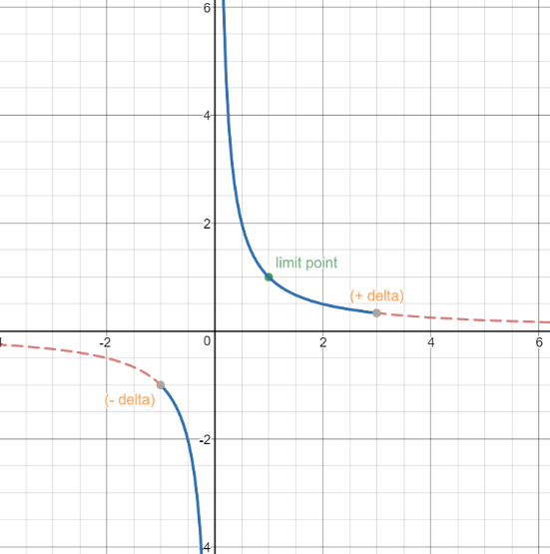

$$x∈(1+2, 1-2)$$

No epsilon band exists where that happens[5], so we cannot let a delta range in this fashion.

* That for any non-linear function, a bounding will need to occur. For example $(x-π)sin⁡(e^{x})$, where ($x-π$) will be replaced by delta. $sin⁡(e^{x})$ will need to be bounded.
* That you could think about the maximum value as the delta band getting as close as possible to the epsilon band without breaking the definition.

For this function, we decided that:

$$δ<1$$

No weird discontinuities happened. In fact, we could choose $δ<300$, or $δ< 0.005$ and it would still work in this scenario.

$$\left|x-5\right|<δ<1$$

$$\left|x-5\right|<1$$

From this we do some manipulations towards bounding the unwanted value:

$$\left|x-5\right|<1$$

$$-1<x-5<1$$

$$9<x+5<11$$

$\left|x+5\right|<11$

*

With this in mind, we can know replace abs(x+5) with 11. Remember that this is the rough work, and when actually proving the limit, you’d want to be able to bring this up quickly. The most efficient way of doing this is by labeling this bound with *, like I’ve done above

$< 11δ$

Following the logic from the previous proof, we’ll define delta in terms of epsilon. We’ll label this ** to be able to reference it in the actual proof.

$δ=\frac{ϵ}{11}$

$$<\frac{11ϵ}{11}=ϵ$$

**

Now for the formal proof:

Let $ϵ>0$ be given. Set delta to be the [6]

Assume $0< \left|x-5\right|<δ$

$$= \left|f\left(x\right)-L\right|$$

$$= \left|x^{2}+2-27\right|$$

$$=\left|x^{2}-25\right|$$

$$= \left|x+5\right|\left|x-5\right|$$

By assumption we get

$$< \left|x+5\right|δ$$

By * we get

$$<11δ$$

By ** we get

$$<\frac{11ϵ}{11}=ϵ Q.E.D.$$

## Hard limits

We’re going to do two hard limits:

$$\lim_{x→\frac{1}{20}}{\frac{1}{x}=20}$$

And the

$$thomae function$$

Starting with the former, we’ll start with what we know and work are way towards the answer:

We have

$$= \left|\frac{1}{x}-20\right|$$

And we and to go towards a function where delta could be swapped in, i.e.:

$$\left|x-\frac{1}{20}\right|$$

For this exercise, it is useful to bring back a previously explored concept of the delta band:

$$delta band=\left(c- δ, c+δ\right)$$

$$delta band=x∈\left(\frac{1}{20}-δ,\frac{1}{20}+δ\right)$$

This concept should be brought up when dealing with non-linear bounds and deltas.

Starting the proof:

$$= \left|\frac{1}{x}-20\right|$$

$$=\frac{20}{\left|x\right|}\left|\frac{1}{20}-x\right|$$

Which is equivalent to:

$$=\frac{20}{\left|x\right|}\left|x-\frac{1}{20}\right|$$

Bc of the abs. val.

We can simply replace delta because it’s linear, so no special manipulation is needed.

$$<\frac{20}{\left|x\right|}δ$$

Going through this section of the proof another way (just to get comfortable):

$$x∈\left(\frac{1}{20}-δ,\frac{1}{20}+δ\right)$$

$$⇔$$

$$\frac{1}{20}-δ<x<\frac{1}{20}+δ$$

$$x-\frac{1}{20}<δ$$

$$<\frac{20}{\left|x\right|}δ$$

Now bound. Note that we cannot set x to be +/- 1 because f(x) diverges to +/- infinity. Looking at these graphs,

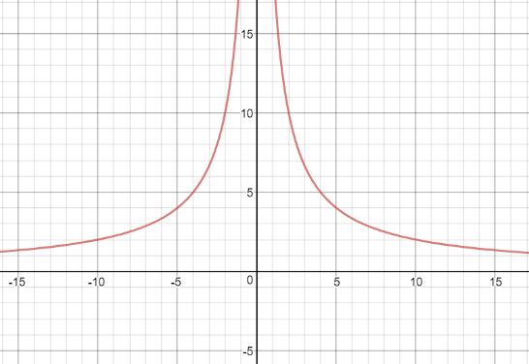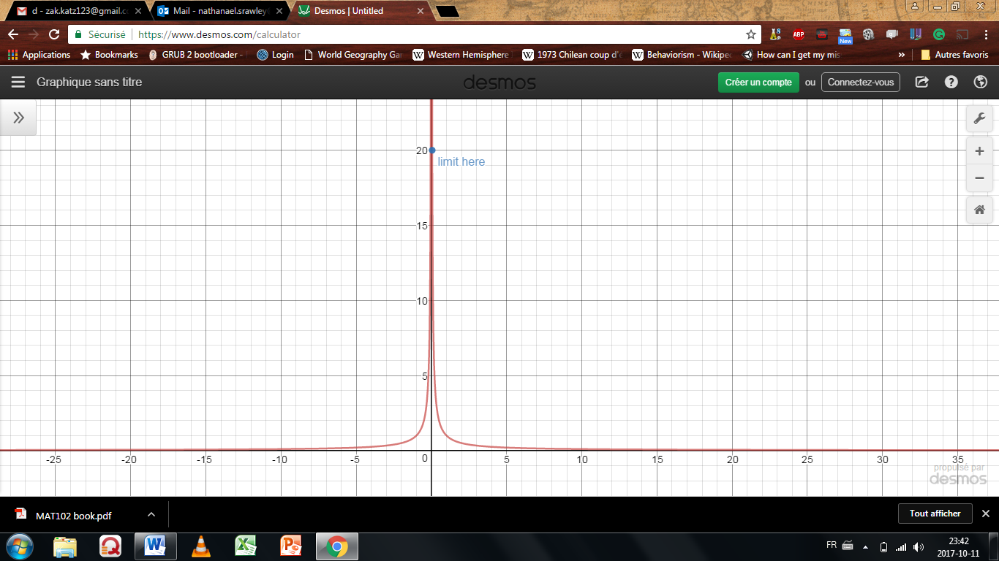

One must choose delta very carefully, less we diverge towards infinity.

$$x∈\left(\frac{1}{20}-δ,\frac{1}{20}+δ\right)$$

In this case, I’ll choose the delta range to be $±\frac{1}{40}$,since the function won’t explode. The function is injective on the range we took, thus either the maximum or minimum value of x will produce the maximum value of our function. Notice the largest delta won’t always be the largest value of the bound.

$$δ≤\frac{1}{40}$$

Note that $≤$ or $<$ won’t effect the overall calculations.

$$x∈\left(\frac{1}{20}-\frac{1}{40},\frac{1}{20}+\frac{1}{40}\right)$$

$$x∈\left(\frac{1}{40},\frac{3}{40}\right)$$

In this case, it’s the small x that produces the largest value for the bound:

$$\left|x-\frac{1}{20}\right|<δ≤\frac{1}{40}$$

$$-\frac{1}{40}<x-\frac{1}{20}<\frac{1}{40}$$

$$\frac{1}{20}<x<\frac{3}{40}$$

$$\frac{1}{400}<\frac{x}{20}<\frac{3}{800}$$

$$400>\frac{20}{x}>\frac{800}{3}$$

$$\left|\frac{20}{x}\right|<400$$

$$<400δ$$

Now simply set $δ=\frac{ε}{400}$, and complete the proof formally.

$$THOMAE FUNCTION:$$

Now we’ll find the limit for this function:

$$f\left(x\right)= \left\{ \begin{aligned}\frac{1}{q} if x=\frac{p}{q} \left(x is rational\right), with p∈Z and q∈N and GCD\left(p,q\right)=1 \\ 0 if x is irrational \end{aligned}\right\}$$

## One-sided limit:

Very similar, here’s the difference:

$$∀ϵ>0, ∃δ>0, s.t. x∈\left(c, c+δ\right)⇒\left|f\left(x\right)-L\right|<ϵ$$

You’re know taking one side of the limit. Ex:

$$\lim_{x→1^{+}}{\sqrt{x-1}=0}$$

***Proof (working backwards):***

$$=\left|\sqrt{x-1}\right|$$

The absolute value could be dropped because the function is strictly positive

$$=\sqrt{x-1}$$

$$<\sqrt{δ}$$

Let $δ=ϵ^{2}$

$$<ϵ Q.E.D.$$

We can also work forwards. Start with delta and work our way towards an epsilon.

1. Start with the delta band:
$$x∈\left(1,1+δ\right)$$

$$1<x<1+δ$$

2. Get x to equal f(x)
$$0<x-1<δ$$

$$0<\sqrt{x-1}<\sqrt{δ}$$

3. Set epsilon equal to delta and reverse the function till you get delta equal to a function of epsilon:
$$\sqrt{δ}=ϵ$$

$$δ= ϵ^{2}$$

4. Plug back into the formula (and since $\sqrt{x-1}$ is strictly positive. No need to add back in the absolute value)

$$0<\sqrt{x-1}<\sqrt{ϵ^{2}}$$

$$\sqrt{x-1}<ϵ$$

$$Q.E.D.$$

These two methods both get you the answer; choose your preferred method.

## How to prove a vertical asymptote limit

First, the formal definition:

We say that

$$\lim_{x→c}{f\left(x\right)=∞}$$

$$∀M>0, ∃δ>0 s.t. 0< \left|x-c\right|<δ ⇒f\left(x\right)>M$$

For a graphical representation of a vertical asymptote:

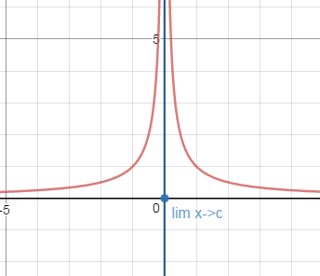

The intuitive idea of a limit hides within M. since M could be anything, including arbitrarily LARGE values, if one can algebraically show f(x) is always bigger than M, then you’ve gotten a vertical asymptote limit. Note

* that M doesn’t need to be > 0, it could be $∈R$, or bigger than 45, just let M be big.
  + It does simplify the math to state that M >0 though. Because when it will come to bounding, keeping M positive makes it easier.
* That there isn’t an f(x) – L, because that doesn’t make sense. We just use f(x). and work a M in the same way we work in an epsilon.
* That we choose the max of the delta’s if f(x) > M

For the opposite way $\left(\lim_{x→c}{f\left(x\right)=-∞}\right)$, simply:

1. M > 0 to M < 0
2. F(x) > M to f(x) < M

Now let’s work through an example. In this example I’ll include a one-sided limit for demonstration:

$$\lim_{x→2^{-}}{\frac{1}{x^{2}-4}= -∞}$$

*[Rough Work]*

$$=f\left(x\right)$$

$$=\frac{1}{(x-2)(x+2)}$$

At this point, we want to bound and replace by delta. Since we’re working with a one-sided limit, and with fractions, we must be careful with how we replace delta and the bound. To start, let’s look at the delta band:

$$x∈\left(2-δ, 2\right)$$

We can only work with one side of the delta band,

$$2-δ<x$$

$$-δ<x-2$$

$$\frac{1}{-δ}>\frac{1}{x-2}$$

Now we can replace $\frac{1}{x-2}$ with

$$>\frac{-1}{δ(x+2)}$$

Notice that the sign swapped. We’re working with a one-sided limit, so we only care what happens to the left when we bound.

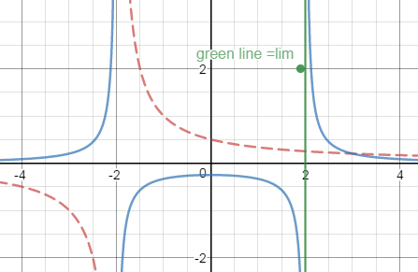

The blue line represents the original function, the red represents what we’re trying to bound, and the green represents the vertical asymptote

Looking at the graph, we see if $δ=1$ $→$ $x∈(1,2)$. The function remains injective, meaning picking the maximum value is easy, and nothing weird will go on. (ex. if we picked $δ=4→ x∈(-2,2)$, we’d fall into the same problem as addressed earlier with picking bad deltas[7] which result’s in a bad bound).

Now applying the math:

$$\left|x-2\right|<δ≤1$$

$$x-2<1$$

$$x+2<5$$

$$\frac{1}{x+2}>\frac{1}{5}$$

No replace back into equation

$$>\frac{-1}{5δ}$$

Now set delta to be

$δ=\frac{-1}{3M}$

$$>\frac{1}{3\frac{-1}{3M}}=M$$

**

Now the 100% proof:

Let M <0 and delta = $\min\left\{1, \frac{-1}{3M}\right\}$

Let’s assume $0<\left|x-2\right|<δ$

$$=f\left(x\right)$$

$$=\frac{1}{(x-2)(x+2)}$$

By assumption

$$f(x)>\frac{-1}{δ(x+2)}$$

By * we get

$$f(x)>\frac{-1}{3δ}$$

By ** we get

$$f(x)>\frac{-1}{3\frac{1}{ 3M}}=M Q.E.D.$$

## How to prove a horizontal asymptote limit

First, the formal definition:

We say that

$$\lim_{x→∞}{f\left(x\right)=L}$$

$$∀ϵ>0, ∃N>0 s.t. x>N ⇒\left|f\left(x\right)-L\right|<ϵ$$

For a graphical representation of a horizontal asymptote:

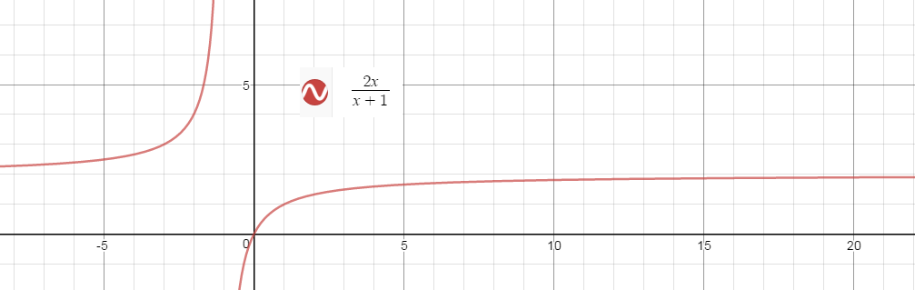The intuition here hides in N. Since epsilon could include points that are arbitrarily far away (like on the graph), and we could pick a point to represent N, we can always find an x that will be greater. Since any epsilon band has to work, arbitrarily small epsilon bands have to also work, which only work for converging functions. Note that technically, for any x you choose, you could always find an epsilon band that will break the definition. This seems to only work for epsilon and bands as the value of f(x) converges to L, as in no finite value will satisfy the definition so we define an intuitive grasp of the value of a function as x approaches infinity.

For the opposite way $\left(\lim_{x→-∞}{f\left(x\right)=L}\right)$, simply:

1. N > 0 to N < 0
2. x >N to x < N

Note:

* There isn’t a delta range anymore, so we no longer work towards a replicable delta. Instead
* When choosing the N, we choose the max of both values we chose if x > N

Now let’s work through an example:

$$\lim_{x→∞}{\frac{x}{x+1}=1}$$

*[Rough Work]*

$$=\left|f\left(x\right)-L\right|$$

We want to work with a single expression:

$$=\left|\frac{x}{x+1}-1\right|$$

$$=\left|\frac{x}{x+1}-\frac{x+1}{x+1}\right|$$

$$=\left|\frac{-1}{x+1}\right|$$

$$=\left|\frac{1}{x+1}\right|$$

$$if 0<n<x then$$

$$=\left|\frac{1}{x+1}\right|<\left|\frac{1}{n+1}\right|$$

The sign reversed because it’s the reciprocal. Note that since x is positive, the functions will always be positive:

$$\frac{1}{x+1}<\frac{1}{n+1}$$

Therefore, set $n=\frac{1-ϵ}{ϵ}$

To get a visual intuition, check:

<https://www.desmos.com/calculator/dvxugd7j8e>

Example: show that

$$\lim_{x→∞}{\frac{\sqrt{x}}{\sqrt{x+1}}}=1$$

$$=\left|f\left(x\right)-L\right|$$

$$=\left|\frac{\sqrt{x}}{\sqrt{x+1}}-1\right|$$

Let

$$n<x$$

$$n+1<x+1$$

Since n and x are positive,

$$\frac{\sqrt{n+1}}{\sqrt{n}}>\frac{\sqrt{x+1}}{\sqrt{x}}$$

$$\frac{\sqrt{n+1}}{\sqrt{n}}-1>\frac{\sqrt{x+1}}{\sqrt{x}}-1$$

Solve:

$$\frac{\sqrt{n}}{\sqrt{n+1}}-1=ϵ$$

$$\frac{\sqrt{n}}{\sqrt{n+1}}=ϵ+1$$

$$\frac{n}{n+1}=ϵ^{2}+2ϵ+1$$

$$\frac{n}{n+1}=\frac{A}{n}+\frac{B}{1}$$

$$1-\frac{1}{n+1 }=ϵ^{2}+2ϵ+1$$

$$-\frac{1}{n+1 }=ϵ^{2}+2ϵ$$

$$\frac{1}{n+1 }={-ϵ}^{2}-2ϵ$$

$$n+1=\frac{1}{{-ϵ}^{2}-2ϵ}$$

$$n=\frac{1}{{-ϵ}^{2}-2ϵ}-1$$

Therefore:

$$ϵ=\frac{\sqrt{\frac{1}{{-ϵ}^{2}-2ϵ}-1+1}}{\sqrt{\frac{1}{{-ϵ}^{2}-2ϵ}-1}}-1>\frac{\sqrt{x+1}}{\sqrt{x}}-1$$

$$\frac{\sqrt{x+1}}{\sqrt{x}}-1<ϵ$$

$$\left|f\left(x\right)-L\right|<ϵ$$

$$Q.E.D.$$

## Proof a limit doesn’t exist:

Formally, this has to do with negating the definition of the limit:

$$¬\left(∃L, ∀ϵ>0, ∃ δ s.t. 0<\left|x-c\right|<δ⇒ \left|f\left(x\right)-L\right|<ϵ\right)$$

$$∀L, ∃ϵ>0, ∀δ s.t. 0<\left|x-c\right|<δ and \left|f\left(x\right)-L\right|≥ϵ$$

Look at predicate logic notes if this negation looks weird. Note that there was an L added at the beginning. This is implied in the regular definition since we only want one limit. While disproving a limit we must be explicit, since we want to show that no value of L can work.

From this, we could work our way through two proofs that a limit doesn’t exist:

$$\lim_{x→0}{\cos\left(\frac{1}{x}\right) and \lim_{x→∞}{sin⁡(x)}}$$

We’re going to start with the first function. Graphically it looks like this:

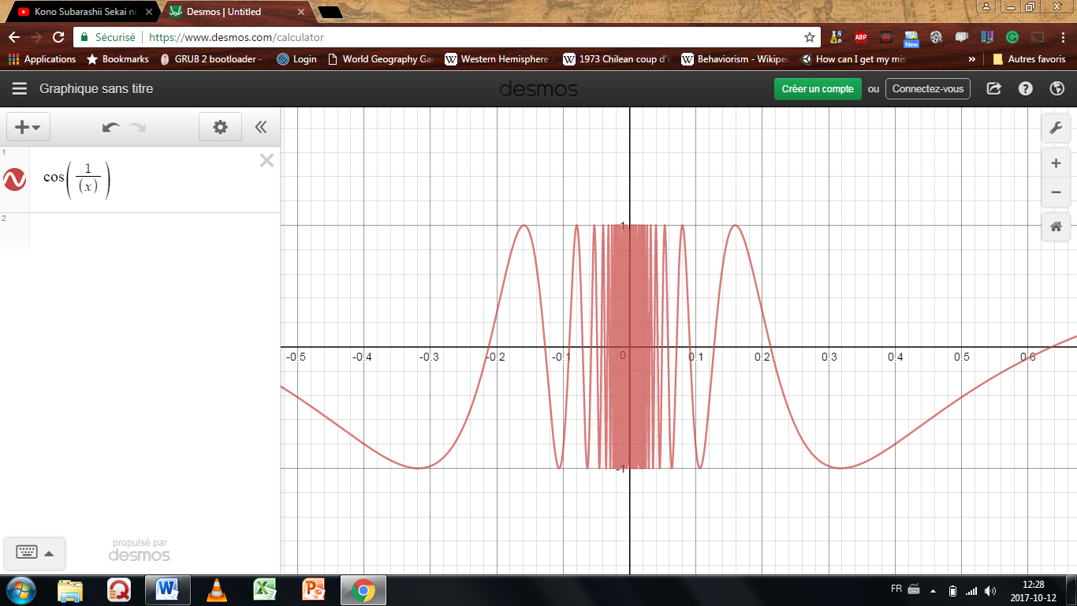  
This graph doesn’t have a limit as x approaches 0.

First, one must points out that this function is bounded. Thus $\left|f(x)\right|≤1$. This means we could get rid of all values of L beyond the bound. We only need to concentrate on the value between $-1<f\left(x\right)<1$. To simplify this even further, note that $-1<f\left(x\right)<0$ acts the same way as its positive counterpart, thus we only need to deal with $0<f\left(x\right)<1$ and the same properties will translate into the negatives. You are allowed to do all of this on your exam. Next; if there is a one sentence explanation that gives away way there isn’t a limit, then give it since it will make it clearer or the examiner. In this case, the 1+

The proof for the second function is similar:

$$\lim_{x→∞}{sin⁡(x)}$$

the function doesn’t converge as x gets arbitrarily large.

HERE

## Building of what we know – simplifying more complex limits with limit laws:

Now we’re starting to move away from formal proving of limits. This section just indicates some rules that should speed up your proofs. Note that the limit of f(x) and g(x) must exist for the definition to hold:

$$suppose f,g \left(a,b\right)∈ R∧c∈R$$

$$\lim_{x→c}{f⁡(x)}=L$$

$$\lim_{x→c}{g⁡(x)}=M$$

$\lim_{x→c}{ αf⁡(x)}=αL$

Proof: $\left|f\left(x\right)-L\right|<\frac{ϵ}{\left|α\right|}$. This formula holds for delta. This means that:

$$\left|αf\left(x\right)-αL\right|<\frac{\left|α\right|ϵ}{\left|α\right|}=ϵ$$

$\lim_{x→c}\left(f\left(x\right)+g\left(x\right)\right)= \lim_{x→c}{f\left(x\right)}+\lim_{x→c}{g\left(x\right)}=L+M$

Proof:

If $0<\left|x-c\right|<δ_{1}⇒\left|f\left(x\right)-L\right|<\frac{ϵ}{2}$

And $0<\left|x-c\right|<δ_{2}⇒\left|g\left(x\right)-M\right|<\frac{ϵ}{2}$

Then let $δ=\min\left\{δ_{1},δ_{2}\right\}$ and $0<\left|x-c\right|<δ$ holds for both:

$$= \left|f\left(x\right)+g\left(x\right)-(L+M)\right|$$

$$≤\left|f\left(x\right)-L\right|+\left|g\left(x\right)-M\right|$$

$$<\frac{ϵ}{2}+\frac{ϵ}{2}$$

$$=ϵ$$

$\lim_{x→c}\left(f\left(x\right)-g\left(x\right)\right)= \lim_{x→c}{f(x)}-\lim_{x→c}{g\left(x\right)}=L-M$

$\lim_{x→c}\left(f\left(x\right)g\left(x\right)\right)= \underset{x→c}{(lim}{f(x)})(\lim_{x→c}{g\left(x\right)}= LM$

$\lim_{x→c}\left(\frac{f\left(x\right)}{g\left(x\right)}\right)=\frac{\lim_{x→c}{f(x)}}{\lim_{x→c}{g\left(x\right)}}=\frac{L}{M} if \lim_{x→c}{g\left(x\right)}≠0$

$\lim_{x→c}{\frac{1}{f\left(x\right)}}=\frac{1}{f\left(c\right)} , f\left(c\right)≠0$

However, you need to prove these laws and be weary of a couple of traps. The main trap to avoid is if a limit doesn’t exist, using the limit laws will not work. Ex:

$$= \lim_{x→0}{x\sin\left(\frac{1}{x}\right)}$$

$$= \lim_{x→0}{x}∙\lim_{x→0}{\sin\left(\frac{1}{x}\right)←limit does not exist}$$

Another example:

$$= \lim_{x→1}\left(\frac{x}{x-1}-\frac{1}{x-1}\right)$$

$$= \lim_{x→1}\left(\frac{x}{x-1}\right)- \lim_{x→1}{\frac{1}{x-1}←limit does not exist}$$

In both cases, the limit laws cannot be applied[8]

## Continuity and discontinuity

$$\lim_{x→c}{f\left(x\right)}=f(c)$$

Comparing the epsilon-delta equation for proving a limit and continuity:

Limit: $∀ϵ>0, ∃ δ s.t. 0<\left|x-c\right|<δ → \left|f\left(x\right)-L\right|<ϵ$

Cont: $∀ϵ>0, ∃ δ s.t. 0<\left|x-c\right|<δ → \left|f\left(x\right)-f(c)\right|<ϵ$

At this point, it should be clear why this is true (Ask Tyler to proof some things with this)

(we’ve proven polynomial, sine cosine, and other functions are continuous)

### Uniform continuity (for MAT157)

This is not needed for MAT137, but will be mentioned for those who are curious:

$$∀ϵ>0, ∃ δ s.t. 0<\left|x-y\right|<δ → \left|f\left(x\right)-f(y)\right|<ϵ$$

Intuitively, this means that if a function grows to quickly (like 1/x near 0), it is not uniformly continuous. This concept is useful for a few theorems.

## Side note

Question for the prof: in one of the CRA questions, there was a quadratic equation. The question was how many roots there are (not specifying real numbers). There was two wrong answer: one root and three roots. Because of the fundamental theorem of algebra, it must have two roots.

Why does

$$-5<x-7<1$$

go to

$$\left|x-7\right|≥0?$$

Also,

$$9< x+5<11$$

$$\left|x+5\right|<11?$$

In the one sided limit section, why can’t I solve it the conventional way taught in class?

Is there anything else I need to restrict for one sided limits. at page 181, you restrict x < 0. Do I need to write that on the test?

Can you *try* to explain $dy=2xdx$ I did some advanced math a little while back and I wonder if I could get it.

p.187, a few of them.

proof the limit for any sin, cos, tan, or other trigs?

p.191 do we neeed to proof the uniqueness of the limit?

Do we need to be able to prove all the limit laws?

How can we prove continuity on an interval?

p.224 overlined

Personal note:

* review P.41 p.58 overlined,

1. You could actually start with x-c, but in every excercice they gave so far, they started with f(x) – L.
2. Remember, it could be what we want but it has to follow the definition, as explained in the paragraph above.
3. Technically, we don’t even need to do that. We’ve proven in a homework that
4. Again, we can for now just replace this value with delta because the function for delta is linear and never does anything weird. However, it will not be so trivial later. Shown in the hard limit proof
5. If you’re skeptical, try making an epsilon band that fits that delta band. It won’t work.
6. If the limit exists, we need to choose a delta range that is the smaller of 1 and $\frac{ϵ}{11}$. This is because we assumed delta to be 1 to find epsilon/11. It will always come out to be the epsilon if you’ve done it correctly. Also, because of the definition of a limit (and assuming the limit exists), if one delta band works, a smaller one will also work.
7. Quesiton : wouldn’t picking (-2,2) be ok in this scenario, since it’s an open interval?
8. Use the squeeze theorem to solve this problem.